## AWARE Version 1.6 KIDS Installation Process

1. Download and extract the AWARE Version 1_6 upgrade to a local location.
   1. The files can be found on the AWARE Subversion site ([https://54.225.241.69/svn/aware/Deployment/AWARE Version 1.1.6](https://54.225.241.69/svn/aware/Deployment/AWARE%20Version%201.1.6) ) or on the Sites AWARE SQL Server (VHACHAAPP11-Charleston or VHALONAPP-Long Beach) **C:\AWARE_INSTALLATION_SOFTWARE** folder. The files should be copied to a location on the workstation desktop.
   2. Subversion will ask for a username and password for authentication (Figure 6 – Subversion Software Download).
   3. The Subversion Username is “**awareva**” and the password is “**P@sswd!**”.

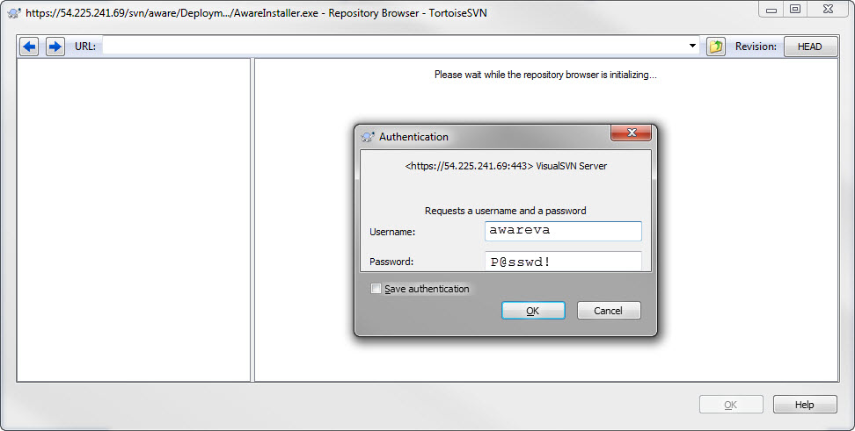

1. **Charleston Files**

KIDS_AWARE_CHA_v_1_6_VMS.zip file (for OpenVMS server) or KIDS_AWARE_CHA_v_1_6.zip (for Linux server.

1. **Long Beach Files**

KIDS_AWARE_LON_v_1_6_VMS.zip file (for OpenVMS server) or KIDS_AWARE_LON_v_1_6.zip (for Linux server.

1. The following KIDS build needs to be installed in this process.
   * VEFA_1_0_6**CHA**.KID (AWARE **Charleston** software)
   * VEFA_1_0_6**LON**.KID (AWARE **Long Beach** software)
2. Access the Kernel Installation and Distribution System Menu [XPD MAIN]
3. Run the Installation option [XPD INSTALLATION MENU]
4. Load the KIDS file by performing the following steps:
   1. Run the Load a Distribution option [XPD LOAD DISTRIBUTION] to load the KIDS distribution.
   2. When prompted, enter the path and the KIDS file name of the KIDS file in step 2 above.
   3. When prompted to continue with the load, enter YES. A Distribution OK! Message will appear when the load is complete.
5. After loading the KIDS file, use the following options to verify the contents of the patch and to back up any affected routines.

* Verify Checksums in Transport Global [XPD PRINT CHECKSUM] – run this option to verify the integrity of the routine in the patch.
* Compare Transport Global to Current System [XPD COMPARE TO SYSTEM] – run this option to view all changes that will be made when the patch is installed. All components (routines, RPCs, and so on) in the patch will be compared.
* Backup a Transport Global [XPD BACKUP] – run this option to create a backup message of any routines exported with the patch. It will NOT backup any of the other changes.

1. After performing the load and any optional verification steps, perform the following steps to install the KIDS file:
   1. Run the Install Package(s) [XPD INSTALL BUILD] option.
   2. When prompted for the install name, enter <AWARE 1.0>.
   3. Answer NO to the following prompts

Want KIDS to INHIBIT LOGONs during the install? NO//

Want to DISABLE Scheduled Options, Menu Options, and Protocols? NO//

Figure - Inhibit Logon Prompt

1. When installation is finished, an Install Complete message will appear.

## Sample KIDS Installation

The sample installation below illustrates the installation of the VEFA_1_0_6XXX.KID, which is located in a temporary path C:\AWARE\. Below are examples of screens that will appear during the installation.

Select OPTION NAME: **XPD INSTALLATION MENU** Installation

**1 Load a Distribution**

2 Verify Checksums in Transport Global

3 Print Transport Global

4 Compare Transport Global to Current System

5 Backup a Transport Global

6 Install Package(s)

Restart Install of Package(s)

Unload a Distribution

Select Installation Option: **1 Load a Distribution**

Enter a Host File: **C:\AWARE\VEFA_1_0_6xxx.KID**

KIDS Distribution saved on Sep 01, 2011@16:30:06

Comment: VEFA ALRE 1.6

This Distribution contains Transport Globals for the following Package(s):

VEFA1 1.6

Distribution OK!

Want to Continue with Load? YES//

Loading Distribution...

VEFA1 1.6

Use INSTALL NAME: VEFA1 1.6 to install this Distribution.

1 Load a Distribution

**2 Verify Checksums in Transport Global**

3 Print Transport Global

4 Compare Transport Global to Current System

5 Backup a Transport Global

6 Install Package(s)

Restart Install of Package(s)

Unload a Distribution

Select Installation Option: **VERify Checksums in Transport Global**

Select INSTALL NAME: VEFA1 1.6 Loaded from Distribution 9/1/11@17:09:41

=> VEFA ALRE 1.6 ;Created on Sep 01, 2011@16:30:06

This Distribution was loaded on Sep 01, 2011@17:09:41 with header of

VEFA ALRE 1.6 ;Created on Sep 01, 2011@16:30:06

It consisted of the following Install(s):

VEFA1 1.6

Want each Routine Listed with Checksums: Yes// **YES**

DEVICE: HOME// TELNET PORT

PACKAGE: VEFA1 1.6 Sep 01, 2011 5:09 pm PAGE 1

-------------------------------------------------------------------------------

0 Routine checked, 0 failed.

1 Load a Distribution

2 Verify Checksums in Transport Global

3 Print Transport Global

4 Compare Transport Global to Current System

5 Backup a Transport Global

**6 Install Package(s)**

Restart Install of Package(s)

Unload a Distribution

Select Installation Option**: INStall Package(s)**

Select INSTALL NAME: VEFA1 1.6 Loaded from Distribution 9/1/11@17:09:41

=> VEFA ALRE 1.6 ;Created on Sep 01, 2011@16:30:06

This Distribution was loaded on Sep 01, 2011@17:09:41 with header of

VEFA ALRE 1.6 ;Created on Sep 01, 2011@16:30:06

It consisted of the following Install(s):

VEFA1 1.6

Checking Install for Package VEFA1 1.6

Install Questions for VEFA1 1.6

Incoming Files:

101.43 ORDERABLE ITEMS (including data)

Note: You already have the 'ORDERABLE ITEMS' File.

I will OVERWRITE your data with mine.

Want KIDS to INHIBIT LOGONs during the install? **NO//**

Want to DISABLE Scheduled Options, Menu Options, and Protocols? **NO//**

Enter the Device you want to print the Install messages.

You can queue the install by enter a 'Q' at the device prompt.

Enter a '^' to abort the install.

DEVICE: HOME//**<RET>** TELNET PORT

VEFA1 1.6

Oct 28, 2013@08:19:36

Installing Data Dictionaries:

Oct 28, 2013@08:19:36

Installing Data:

Oct 28, 2013@08:19:36

Updating Routine file...

Updating KIDS files...

VEFA1 1.6 Installed.

Oct 28, 2013@08:19:36

No link to PACKAGE file

NO Install Message sent

100% Sample KIDS Installation Process (Continued)

Complete

Install Completed